Jennifer Stegina

2 September 2019

CIS 250

**Unit 2 Guided Practice 1**

The following questions come from the Task examples of each section of Chapter 3 in your textbook. After you are finished, please submit a Microsoft Word file that contains screenshots of the SQL statements and the output. **Please place a comment line in your Query window that includes your name.** Your document should be named **U2_GuidedPractice1_Lastname.docx**.

(3-1) Question 1:

Write a query to list all employees who do not report to employee 203, Martha Woods. Include rows with a null value in the *manager_id* column. Show the following columns: *employee_id*, *first_name*, *last_name*, and *manager_id*.

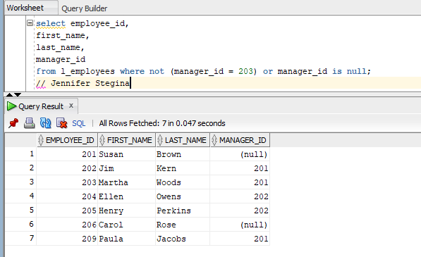

(3-2) Question 2:

Write a query showing the *employee_id*, *first_name*, *last_name*, and *manager_id* of the employees having all of the following conditions:

* *dept_code* is not act or mkt
* *last_name* does not begin with any letter from J to M
* *last_name* does not end with S
* *manager_id* is not a null value

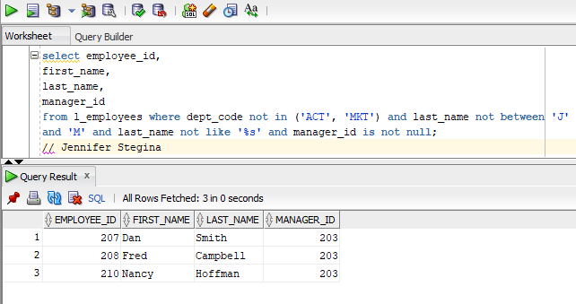

(3-4) Question 3:

Write a query showing the employees whose employee IDs are 203, 204, or 205, list only the ones in the sales department.

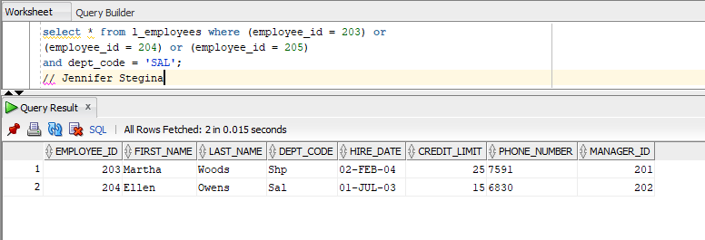

(3-5) Question 4:

Write a query showing the hard-coded values in the select clause. Show a text value, a numeric value, a date value, and a null value.

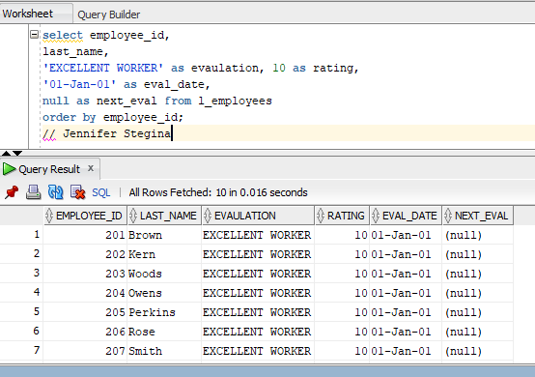

(3-6) Question 5:

Write the code that show the select statement from the previous section using a table of constants instead of hard-coded literals.

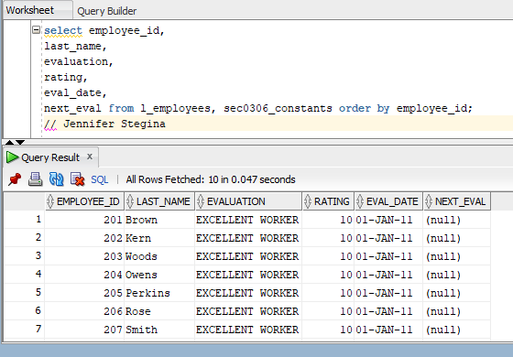

(3-9) Question 6:

Write the procedure that the demonstration database distributed with Oracle XE is a case-sensitive database.

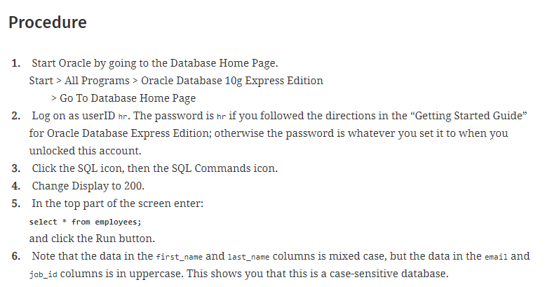

(Patrick, 2009). This image from the textbook shows a procedure to illustrate it. My image from the last problem shows the case sensitivity to be true as well. (See Below)



You have both cases of character within this table as illustrated above.

(3-9) Question 7:

Show one method to deal with case sensitivity.

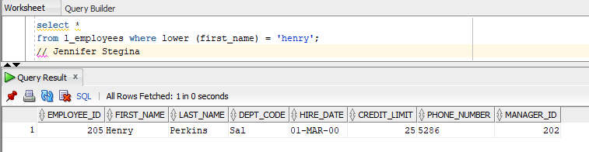

(3-9) Question 8:

Write SQL code that uses the common compromise to put all literals in uppercase.

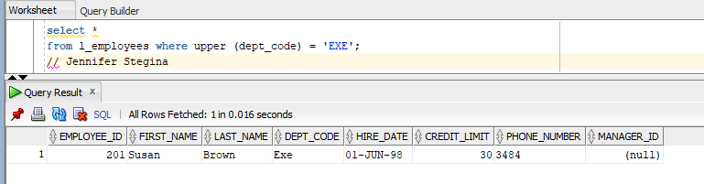

(3-14) Question 9:

Show that the logical condition

"*the price increase is greater than 20 cents*"

divides rows of the *l_foods* table into three separate parts:

■ The rows where it is a true statement

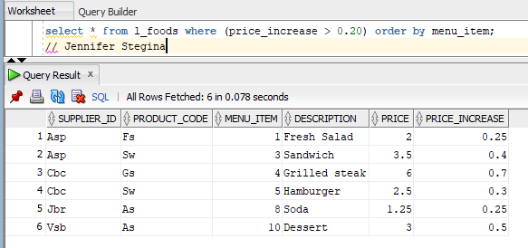

■ The rows where it is a false statement

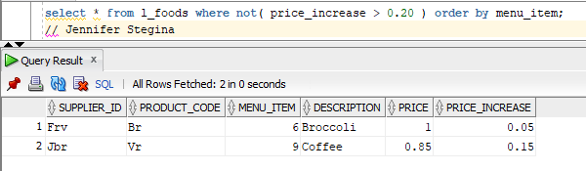

■ The rows where where we do not yet know if the statement is true or false

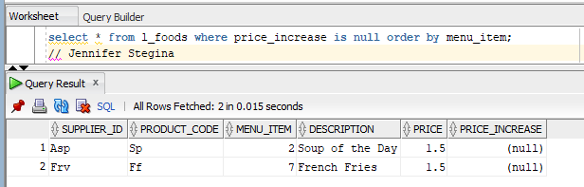

(3-15) Question 10:

Show the error messages produced by the code:

*select first_name,*

*last_name,*

from *l_employees;*

The problem with this code is that there is a comma after *last_name*.

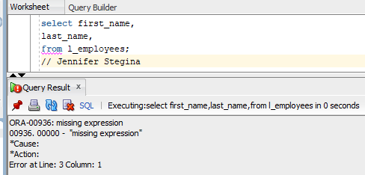

# References

Patrick, J. (2009). *SQL Fundamentals, Third Edition.* Boston: Prentice Hall.